Bellabeat Case Study: How Can a Wellness Company Play It Smart

By **Andi Firmansyah –** [LinkedIn](https://www.linkedin.com/in/andifirmansyah/details/certifications/) | [Another Portfolio](https://andif-portfolio.webflow.io/)

Created at 4th July 2024

# Introduction

Urška Sršen and Sando Mur founded Bellabeat, a high-tech company that produces health-focused smart products. Sršen uses her background as an artist to develop beautifully designed technology that informs and inspires women around the world. Collecting data on activity, sleep, stress, and reproductive health has enabled Bellabeat to empower women with knowledge about their own health and habits. Since its founding in 2013, Bellabeat has grown rapidly and quickly positioned itself as a technology-driven wellness company for women.

In 2016, Bellabeat has opened offices around the world and launched several products. Bellabeat products are available with a growing number of online retailers, as well as through e-commerce channels on [**their websites**](https://bellabeat.com/). The company has invested in traditional advertising media, such as radio, out-of-home billboards, print media, and television, but focuses on digital marketing extensively. Bellabeat invests throughout the year in Google Search, maintains active Facebook and Instagram pages, and consistently engages consumers on Twitter. In addition, Bellabeat launches video ads on Youtube and displays ads on the Google Display Network to support campaigns around important marketing dates.

Sršen knew that analyzing Bellabeat's available consumer data would reveal more opportunities for growth. He asked the marketing analytics team to focus on Bellabeat products and analyze smart device usage data to gain insights into how customers were using their smart devices. Then, using this information, he wanted high-level recommendations on how these trends could help shape Bellabeat's marketing strategy.

# Scenario

You are a junior data analyst working in the marketing analyst team at [**Bellabeat**](https://bellabeat.com/), a high-tech manufacturer of women's health products. Bellabeat is a successful small company, but they have the potential to become a bigger player in the global smart device market. Urška Sršen, co-founder and Chief Creative Officer of Bellabeat, believes that analyzing fitness data from smart devices can help unlock new growth opportunities for the company. You have been asked to focus on one of Bellabeat's products and analyze smart device data to gain insights into how consumers use their smart devices. The insights you uncover will help guide the company's marketing strategy. You will present your analysis to Bellabeat's executive team and deliver high-level recommendations for Bellabeat's marketing strategy.

# Characters and Products

## Characters

* + **Urška Sršen:** Bellabeat co-founder and Chief Creative Oﬃcer.
* **Sando Mur:** Mathematician and co-founder of Bellabeat; key member of Bellabeat's executive team.
* **Bellabeat Marketing Analysis Team:** A team of data analysts responsible for collecting, analyzing, and reporting data that can help shape Bellabeat's marketing strategy. You joined the team six months ago and have been busy learning about Bellabeat's mission and business goals - and how you, as a junior data analyst, can help Bellabeat achieve them.

## Products

* + **Bellabeat App:** The Bellabeat app provides health data related to users' activity, sleep, stress, menstrual cycle and habits. This data can help users to better understand their current habits and make healthy decisions. The Bellabeat app is connected to their smart health product line.
  + ***Leaf*:** Bellabeat's classic health tracker that can be worn as a bracelet, necklace or clip. The Leaf tracker connects to the Bellabeat app to track activity, sleep and stress.
  + **Time:** This fitness watch combines the timeless look of a classic timepiece with smart technology to track user activity, sleep and stress. The Time watch connects to the Bellabeat app to give you insights into your daily health.
  + ***Spring*:** A water bottle that tracks daily water intake using smart technology to ensure that you are well hydrated throughout the day. The Spring bottle connects to the Bellabeat app to track your hydration levels.
  + **Bellabeat Membership:** Bellabeat also offers a subscription-based membership program for users. The membership gives users 24/7 access to fully personalized guides, which are related to nutrition, activity, sleep, health and beauty, and habits based on their lifestyle and goals.

To analyze Bellabeat products based on the dataset provided, it will go through the stages of the data analysis phases, i.e. Ask, Prepare, Process, Analyze, Share, and Act, which will be explained in more detail in the following points.

# Ask – Understand the Problem

Sršen asks you to analyze smart device usage data to gain insights into how consumers use non-Bellabeat smart devices. He then wants you to select one Bellabeat product to apply these insights in your presentation.

As a junior data analyst, I will choose the Leaf Smart Device product and look at user habits through the device. This will lead us to see patterns and trends and draw conclusions that can lead Bellabeat to develop their products. The expected end result is of course recommendations that can improve the quality of user health, especially Bellabeat customers who use smart devices to monitor their health.

The stakeholders who were directly involved in this project are as follows.

* + **Urška Sršen:** Bellabeat co-founder and Chief Creative Oﬃcer.
* **Sando Mur:** Mathematician and co-founder of Bellabeat.
* **Bellabeat Marketing Analysis Team:** A team of data analysts.

# Prepare – What Do We Need?

Sršen encourages you to use public data that explores the daily habits of smart device users. He directs you to specific datasets: [**FitBit Fitness Tracker**](https://www.kaggle.com/datasets/arashnic/fitbit) by Möbius and covered by covered by the CCO Public Domain License which includes minute levels for physical activity, heart rate, and sleep monitoring. This includes information on daily activity, steps, and heart rate.

To answer the business problem to be solved, a dataset that is relevant to the problem and question is required. In this case, an external dataset is used, namely the FitBit Fitness Tracker which is a dataset generated by respondents to a survey distributed via Amazon Mechanical Turk between 03-12-2016-05-12-2016. 33 eligible Fitbit users consented to the submission of personal tracker data, including minute-level output for physical activity, heart rate, and sleep monitoring. Individual reports can be parsed by export session ID (column A) or timestamp (column B). Variations between outputs represent the use of different types of Fitbit trackers and individual tracking behaviors/preferences. The owner of the dataset is Möbius and it is covered by the CCO Public Domain License which can be accessed at the .

The downloaded dataset is wrapped in one zip file and there are 2 folders named **mturkfitbit_export_3.12.16-4.11.16** and **mturkfitbit_export_4.12.16-5.12.16 (which will be used)**.

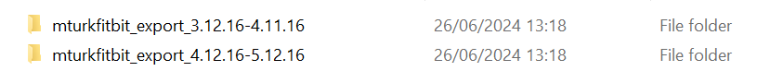

The folder contains 18 datasets and the **dailyActivity_merged** dataset will be used during the analysis process in this analysis project.

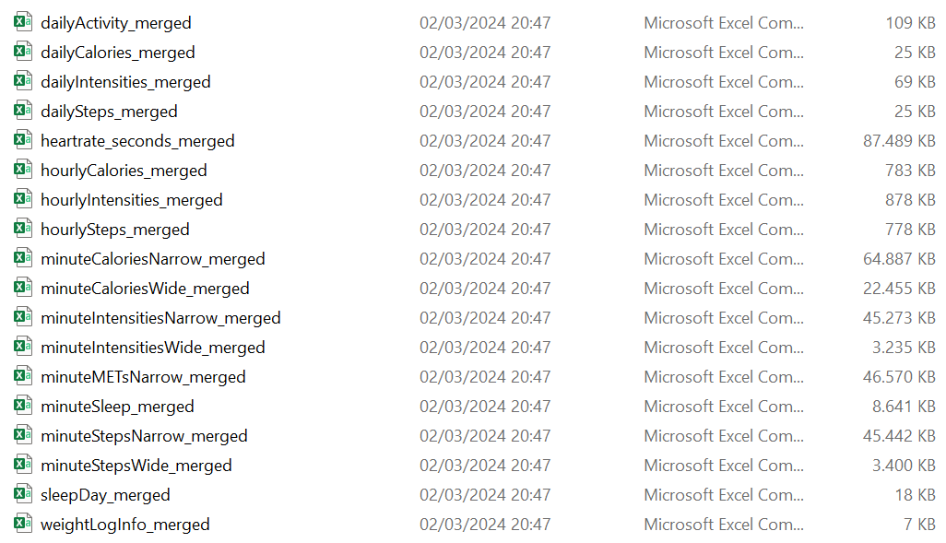

## Are there issues with bias or credibility in this data? Does your data ROCCC?

What is good or excellent may sound very subjective. For example, when you ask me what fruit has the best sweetness? Maybe I will answer that mango is the fruit that has the best sweetness, but maybe you will disagree and prefer watermelon is the fruit with the best sweetness. It cannot be determined who is wrong and right because good and good are very subjective things. Although some things can be applied like that, but we all probably agree that when we want to start analyzing data, we must start from a good dataset. So to ensure that the data we will use for analysis is good, there are several things that can be used as a benchmark, namely ROCCC. ROCCC (Reliable, Originality, Comprehensive, Current, Cited) are things that must be considered when choosing data for analysis purposes which can be seen in the points below.

* **Reliability (LOW)**: Data can be used to provide accurate, comprehensive and unbiased information that has been evaluated and determined for use. In reality, the data used was only taken from 33 participants. This could lead to potentially biased data plus incomplete information such as gender and age. However, this is still tolerable considering that Bellabeat is a gadget company geared towards women.
* **Originality (LOW)**: In some cases the data is not collected directly by the relevant company (first party), but it is also possible that the data is collected from a second or third party. In this project, data is collected from a third party, namely the Fitbit Fitness Tracker Data dataset via Amazon Mechanical Turk.
* **Comprehensive (HIGH)**: The best data sources contain all the essential information needed to answer a question or find a solution. Just like when you want to buy a gadget in an online store, of course you don't buy the gadget after seeing only one good review, of course you will look for more in-depth information to decide whether to buy the gadget or not. The same thing should be done for your data analysis. In the dataset provided, it includes a lot of information that can be relevant for analysis such as daily activity intensity, calories used, daily steps taken, daily sleep time, and weight record.
* **Current (MEDIUM)**: Good data for use in analysis is data that is up-to-date, not obsolete, and relevant because data is constantly updated and environmental conditions will be different every time. As long as the span of years for the data used is not more than 10 years, then the data can still be used. But keep in mind that try to use the most recent data for more accurate results. The FitBit dataset was updated recently regarding metadata and so on, but the data is still in 2016 (which is 8 years ago). However, the data can still be used.
* **Cited (HIGH)**: When you tell a friend that you just read the news about the making of the Despicable Me movie sequel, you've quoted a source. Quoting is an activity of taking words or sentences from a book, magazine, or other source, or quoting an essay. In data, we must know clearly where the data comes from? Is the data collector or creator credible? A data is said to be well cited if the source is clear and credible. In the dataset used, the data collector and source are well-cited with Amazon Mechanical Turk serving as the data collector.

# Process – Make It Usable

At this stage, processing is carried out on the dataset used. The data to be used must be clean from duplicate data, empty data, incorrect data format (such as total step data with string data type), and the most important thing is to see whether the data used is biased or not because data that is biased will not be representative of the population or phenomenon of study, our issue we are trying to solve. The following are some of the processing steps previously performed using Spreadsheet.

* Filtering and sorting the dataset to see the blanks contained in the dataset by using the Create Filter feature.

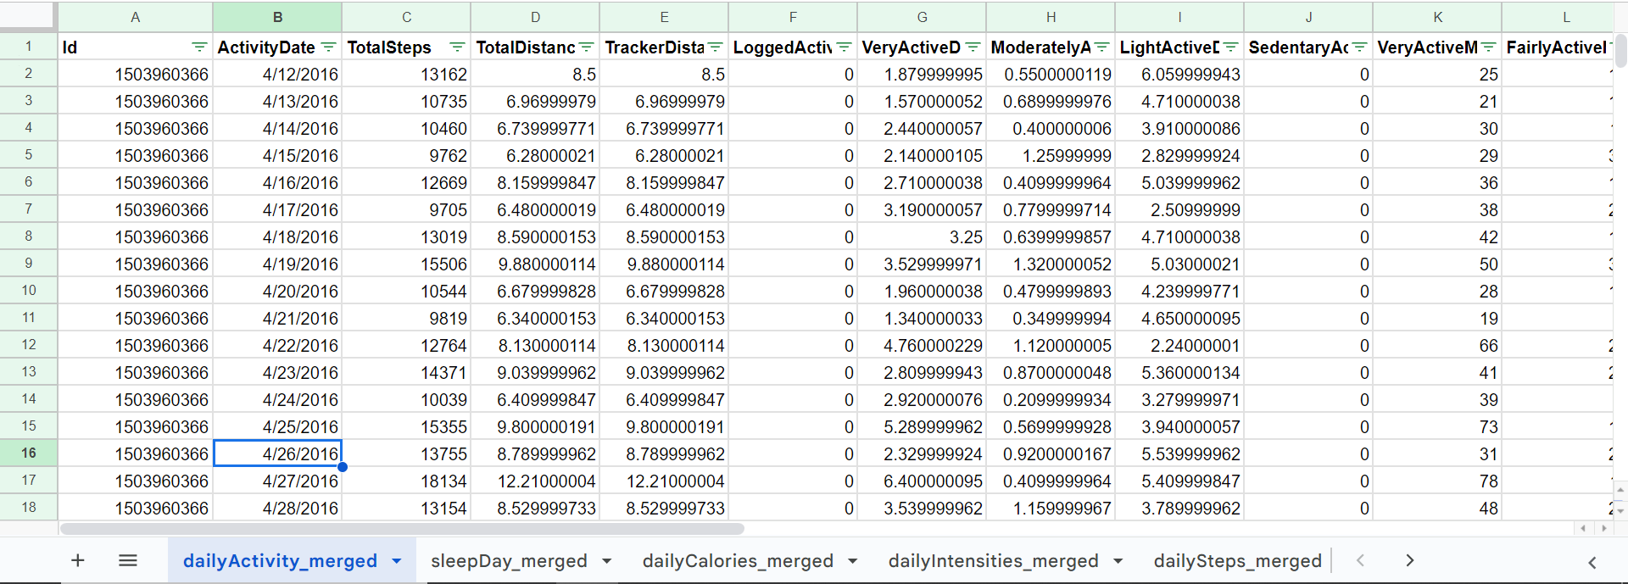

* Checking whether there is duplicate data or not to avoid bias by using the Data Cleanup feature.

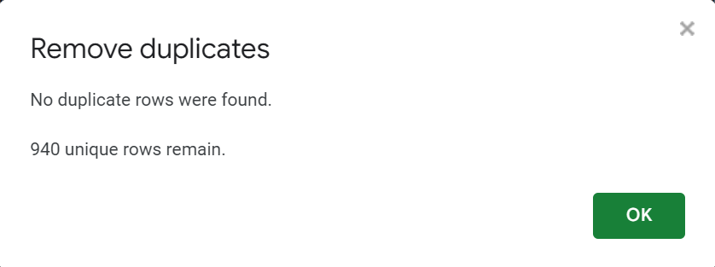

* Checking whether the data was actually taken from 33 participants by using the formula CONCATENATE("Total unique ID: ", COUNT(UNIQUE(A2:A941))).

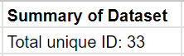

# Analyze – Tell Me The Story

At this step, as an analyst we must be able to provide useful conclusions for the company based on the facts provided by the data. As a first step, I wanted to check the frequency of use of FitBit gadgets by their users. To find out the frequency of use, the following query is used.

SELECT

  id,

  COUNT(id) as total_uses

FROM `sodium-cat-362801.bellabeat_dataset.dailyActivity`

GROUP BY id

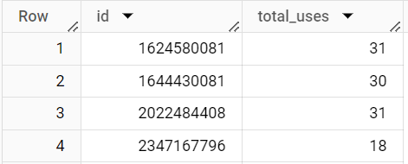

Check the frequency of the most (frequent) usage by using the order by **total_id DESC** clause. It can be seen that the highest frequency is 31.

SELECT

  id,

  COUNT(id) as total_uses

FROM `sodium-cat-362801.bellabeat_dataset.dailyActivity`

GROUP BY id

ORDER BY total_id DESC

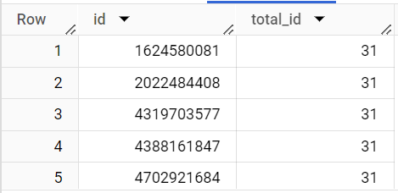

Check for least (rare) usage by using the order by **total_id ASC** clause. It can be seen that the lowest frequency is 4.

SELECT

  id,

  COUNT(id) as total_uses

FROM `sodium-cat-362801.bellabeat_dataset.dailyActivity`

GROUP BY id

ORDER BY total_id ASC

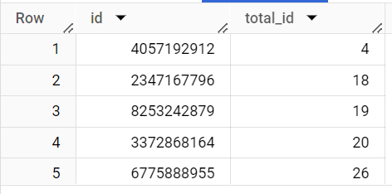

The results show that the range of gadget usage for each user starts from 4 (least frequent) to 31 (most frequent). We can classify them into three categories as follows.

* + **Active Users** (high frequency of use between 21-31)
  + **Moderate Users** (medium frequency of use between 11-20)
  + **Light Users** (low frequency of use between 0-10)

Use the following query to classify users.

SELECT

  id,

  COUNT(id) as total_uses,

CASE

  WHEN COUNT(id) BETWEEN 0 AND 10 THEN 'light_user'

  WHEN COUNT(id) BETWEEN 11 AND 20 THEN 'moderate_user'

  WHEN COUNT(id) BETWEEN 21 AND 31 THEN 'active_user'

END AS users_classification

FROM `sodium-cat-362801.bellabeat_dataset.dailyActivity`

GROUP BY id

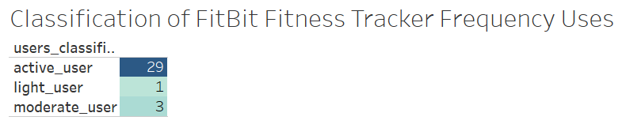

It can be seen that 29 users (87.87%) are active users, 3 users (9.09%) are moderate users, and 1 user (3.03%) is a light user. After classifying users based on the frequency of use of FitBit gadgets, the next step is to analyze descriptive statistics, namely the minimum value, maximum value, and average of each of the following features.

* totalSteps
* totalDistance
* veryActiveMinutes
* fairlyActiveMinutes
* lightlyActiveMinutes
* sedentaryActiveMinutes
* calories

Untuk melakukan analisis statistik deskriptif dapat menggunakan fungsi MIN() untuk mengetahui nilai minimum, fungsi MAX() untuk mengetahui nilai maksimal, dan fungsi AVG() untuk mengetahui nilai rata-rata dari suatu kumpulan data. Pada query di bawah digunakan fungsi ROUND() yang berfungsi untuk membulatkan angka di belakang koma. Sehingga keseluruhan query akan seperti di bawah ini.

SELECT

  id,

  ROUND(MIN(TotalSteps), 2) AS minimum_total_steps,

  ROUND(MAX(TotalSteps), 2) AS maximum_total_steps,

  ROUND(AVG(TotalSteps), 2) AS average_total_steps,

  ROUND(MIN(TotalDistance), 2) AS minimum_total_distance,

  ROUND(MAX(TotalDistance), 2) AS maximum_total_distance,

  ROUND(AVG(TotalDistance), 2) AS average_total_distance,

  ROUND(MIN(VeryActiveMinutes), 2) AS minimum_very_active_minutes,

  ROUND(MAX(VeryActiveMinutes), 2) AS maximum_very_active_minutes,

  ROUND(AVG(VeryActiveMinutes), 2) AS average_very_active_minutes,

  ROUND(MIN(FairlyActiveMinutes), 2) AS minimum_fairly_active_minutes,

  ROUND(MAX(FairlyActiveMinutes), 2) AS maximum_fairly_active_minutes,

  ROUND(AVG(FairlyActiveMinutes), 2) AS average_fairly_active_minutes,

  ROUND(MIN(LightlyActiveMinutes), 2) AS minimum_lightly_active_minutes,

  ROUND(MAX(LightlyActiveMinutes), 2) AS maximum_lightly_active_minutes,

  ROUND(AVG(LightlyActiveMinutes), 2) AS average_lightly_active_minutes,

  ROUND(MIN(Calories), 2) AS minimum_calories,

  ROUND(MAX(Calories), 2) AS maximum_calories,

  ROUND(AVG(Calories), 2) AS average_calories

FROM

  `sodium-cat-362801.bellabeat_dataset.dailyActivity`

GROUP BY id

ORDER BY id

Next, analyze the dataset to identify the highest average minutes spent actively per individual from the following points.

* veryActiveMinutes
* fairlyActiveMinutes
* lightlyActiveMinutes
* sedentaryMinutes

Use the following query to find the average value of the activities performed by the user.

SELECT

  id,

  AVG(VeryActiveMinutes) AS average_very_active_minutes,

  AVG(FairlyActiveMinutes) AS average_fairly_active_minutes,

  AVG(LightlyActiveMinutes) as average_lightly_active_minutes,

  AVG(SedentaryMinutes) AS average_sedentary_minutes

FROM

  `sodium-cat-362801.bellabeat_dataset.dailyActivity`

GROUP BY id

ORDER BY 2, 3, 4, 5 DESC

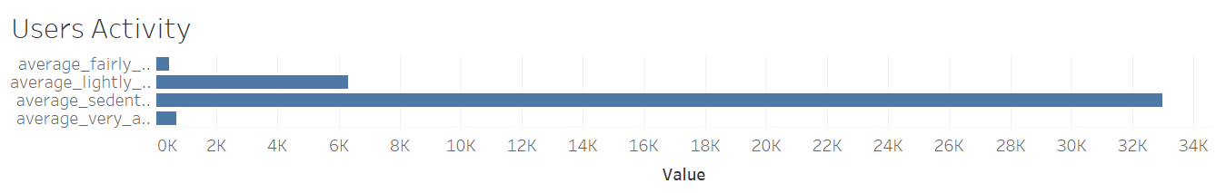

Perform the same analysis but with the highest average daily minutes shown.

SELECT

  FORMAT_DATE('%A', DATE(ActivityDate)) AS day_of_week,

  AVG(VeryActiveMinutes) AS average_very_active_minutes,

  AVG(FairlyActiveMinutes) AS average_fairly_active_minutes,

  AVG(LightlyActiveMinutes) as average_lightly_active_minutes,

  AVG(SedentaryMinutes) AS average_sedentary_minutes

FROM

  `sodium-cat-362801.bellabeat_dataset.dailyActivity`

GROUP BY day_of_week

ORDER BY 2, 3, 4, 5 DESC

It can be seen that sedentary users dominate on all days. This can be a concern for users to be able to do more physical activity to maintain health such as walking more for their own health.

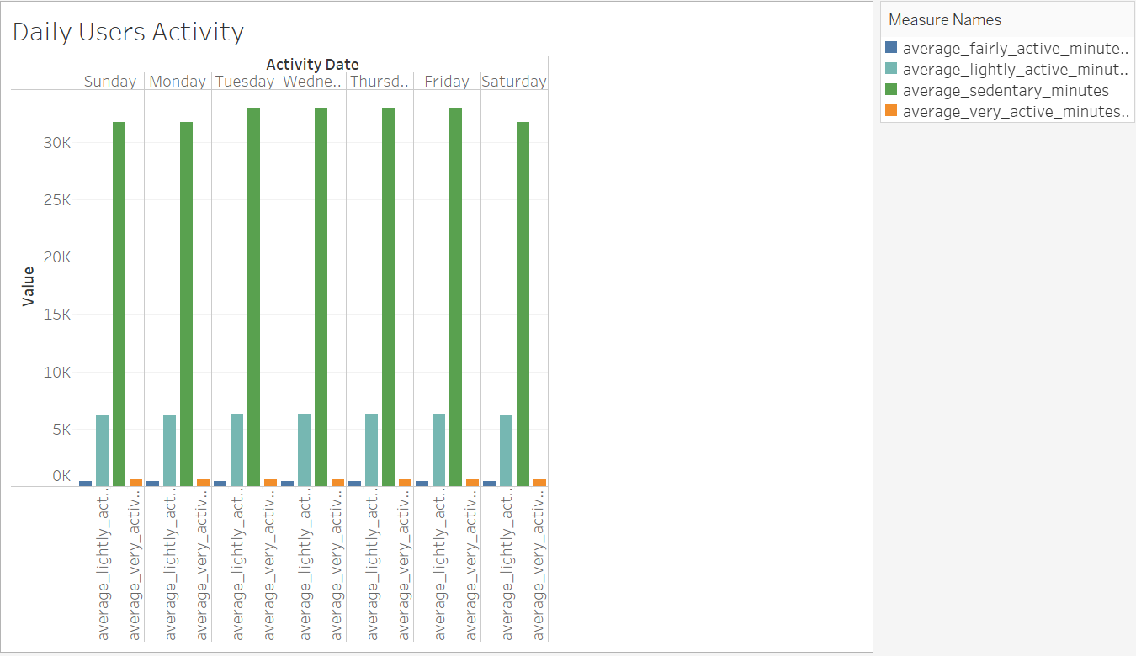

A study conducted by Catrine Tudor-Locke and David R. Bassett Jr entitled "[**How many steps/day are enough?**](https://pubmed.ncbi.nlm.nih.gov/14715035/?source=post_page-----c18835475563--------------------------------)" says there are several categories of recommended number of steps to maintain a healthy lifestyle. The following is a classification of recommended steps to maintain a healthy life.

* **Sedentary lifestyle** index < 5000 steps a day
* **low-active** 5000 ≤ 7499 steps a day
* **Somewhat active** 7500 ≤ 9999 steps a day
* **Active** > 10000 steps a day
* **Highly Active** >12500 steps a day

Berdasarkan klasifikasi dari rekomendasi jumlah langkah setiap harinya maka buatlah klasifikasi pada dataset dengan menggunakan query berikut.

SELECT

  id,

  AVG(TotalSteps) AS average_total_steps,

  CASE

    WHEN ROUND(AVG(TotalSteps), 2) < 5000 THEN 'sedentary_lifestyle'

    WHEN ROUND(AVG(TotalSteps), 2) BETWEEN 5000 AND 7499 THEN 'low_active'

    WHEN ROUND(AVG(TotalSteps), 2) BETWEEN 7500 AND 9999 THEN 'somewhat_active'

    WHEN ROUND(AVG(TotalSteps), 2) BETWEEN 10000 AND 12500 THEN 'active'

    WHEN ROUND(AVG(TotalSteps), 2) > 12500 THEN 'highly_active'

  END AS total_step_indices

FROM

  `sodium-cat-362801.bellabeat_dataset.dailyActivity`

GROUP BY id

It can be seen that only 7 out of 33 users fulfill the walking recommendation, namely 5 people are classified as active and 2 people are classified as highly_active.

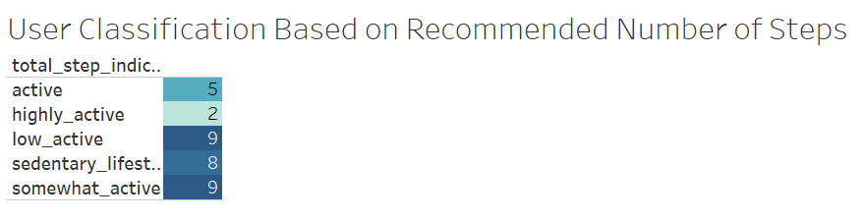

WHO (World Health Organization) through its article says that adults aged between 18-64 years old should do at least 150-300 minutes of moderate-intensity aerobic physical activity (accessible through the [**following link**](https://www.who.int/news-room/fact-sheets/detail/physical-activity?source=post_page-----c18835475563--------------------------------)). After reading the article, I made a classification based on the level of recommendation from the WHO, which is as follows.

* exceeds_WHO_recommendation: when users spend more than 300 minutes.
* meets_WHO_recommendation: when users spend between 150 to 300 minutes.
* does_not_meets_WHO_recommendation: when the user spends less than 150 minutes.

Use the query below to classify physical activity based on WHO recommendations.

SELECT

  id,

  AVG(VeryActiveMinutes) + AVG(FairlyActiveMinutes) + AVG(LightlyActiveMinutes) AS total_average_active_minutes,

  CASE

    WHEN AVG(VeryActiveMinutes) + AVG(FairlyActiveMinutes) + AVG(LightlyActiveMinutes) > 300 THEN 'exceeds_WHO_recommendation'

    WHEN AVG(VeryActiveMinutes) + AVG(FairlyActiveMinutes) + AVG(LightlyActiveMinutes) BETWEEN 150 AND 300 THEN 'meets_WHO_recommendation'

    WHEN AVG(VeryActiveMinutes) + AVG(FairlyActiveMinutes) + AVG(LightlyActiveMinutes) < 150 THEN 'does_not_meets_WHO_recommendation'

  END AS WHO_recommendation

FROM

  `sodium-cat-362801.bellabeat_dataset.dailyActivity`

GROUP BY ide

As can be seen, most users meet the recommendation criteria and even some users exceed the WHO recommendations. While 6 out of 33 users fall into the category below WHO recommendations.

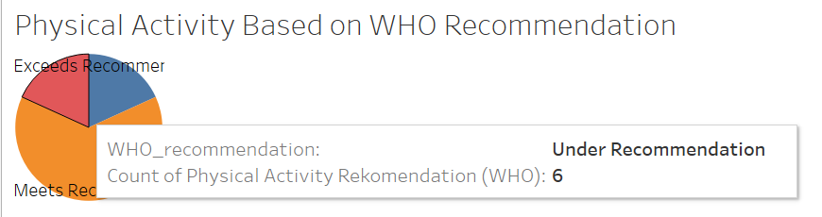

Next, analyze by looking at the average of all major activities recorded in the daily activity table by day_of_the_week.

SELECT

  FORMAT_DATE('%A', DATE(ActivityDate)) AS day_of_week,

  AVG(TotalSteps) AS average_steps,

  AVG(TotalDistance) AS average_distance,

  AVG(Calories) AS average_calories

FROM

  `sodium-cat-362801.bellabeat_dataset.dailyActivity`

GROUP BY day_of_week

ORDER BY average_steps DESC

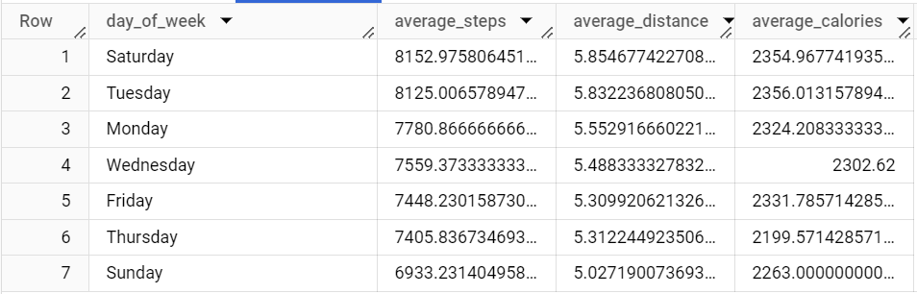

It can be seen that the average number of calories burned on Tuesday is the highest compared to other days in one week, which is 2,536 with a total of 8,125 steps. Meanwhile, the highest distance and total steps were on Saturday. This is possible because Saturday is a weekend where the habit of many people will do physical activities such as exercise in order to diet and maintain a healthy quality of life.

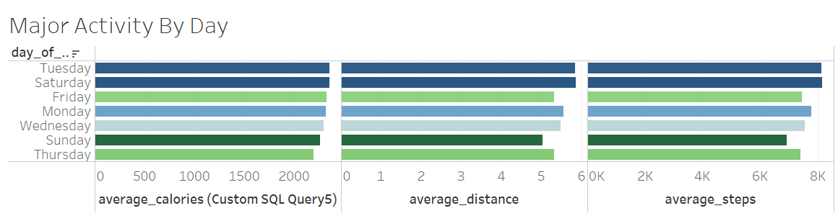

# Share – Get Different Views

Based on the results of the analysis that has been carried out using the FitBit Fitness Tracker dataset, several conclusions can be seen from the following points.

* A total of 87.87% of users are active users of FitBit Fitness Tracker gadgets.
* The fact found is that the average user spends more time when he is silent than doing any activity.
* A total of 21.21% of users meet the ideal step movement which is characterized by meeting the recommendation to do walking activities for at least 10,000 steps per day. This could be due to most users using motorized vehicles to get to their destination.
* 81.81% have a healthier lifestyle by doing more than 150 minutes of physical activity per day. This shows a positive trend where most users are aware of the importance of daily physical activity to keep their bodies fit.
* Weekends, especially on Saturdays, are the best days because many users do physical activities so that their calories will be burned and life will become healthier.

# ACT – We Know The Problem, Let’s Solve It!

Here are some suggestions that I can make for Bellabeat's stakeholders which can be seen in the following points.

* The marketing team is expected to be able to raise users' awareness that healthy living is important and expensive but easy to obtain. Give users the knowledge that healthy living is simple but has a tremendous impact on their present and future.
* Create a gamification, which is a method adapted from games to monitor their achievements in exercise so as to increase the attractiveness of users to compete in terms of improving their health and living standards.
* Since the most possible days for users to do intense physical activity are only on weekends, especially on Sundays, then try to influence users to do physical activity on weekdays as well. No need to do strenuous physical activities such as going to the gym or so on, just give them an exercise suggestion that can be done at the office, at school, or wherever they are doing activities so that they keep doing exercise for a healthier life.
* Since Bellabeat is a gadget specialized for women, which means it is segmented, Bellabeat can do a comparison of women who use Bellabeat products to track their activities and women who do not use the product. Compare which one has a better track record and use that information to encourage new users to use Bellabeat products.